Blood Transfusion

Components of Blood
- Formed elements-Cells
  - Erythrocytes (RBCs)
  - Leukocytes (WBCs)
  - Thrombocytes (platelets)
- Plasma
  - 90% water
  - 10% solutes
  - Proteins, clotting factors

What can we give?
- Whole blood
- Packed RBC (PRBC)
- Platelets
- Fresh Frozen Plasma (FFP)
- Granulocytes
- Cryoprecipitate
- Factor VIII
- Albumin

Antigens
- Definition: a substance capable of stimulating the production of an antibody and then reacting with that antibody in a specific way
- Inherited
- Found on red cells
- ABO, Rh (D antigen)

Antibodies
Definition: protein produced by the immune system that destroys or inactivates a particular antigen
Produced as a result of antigenic reactions
Found in plasma

Agglutination
- Caused by reaction between antigens and antibodies
- Type & screen
- Type & cross

Giving and Receiving
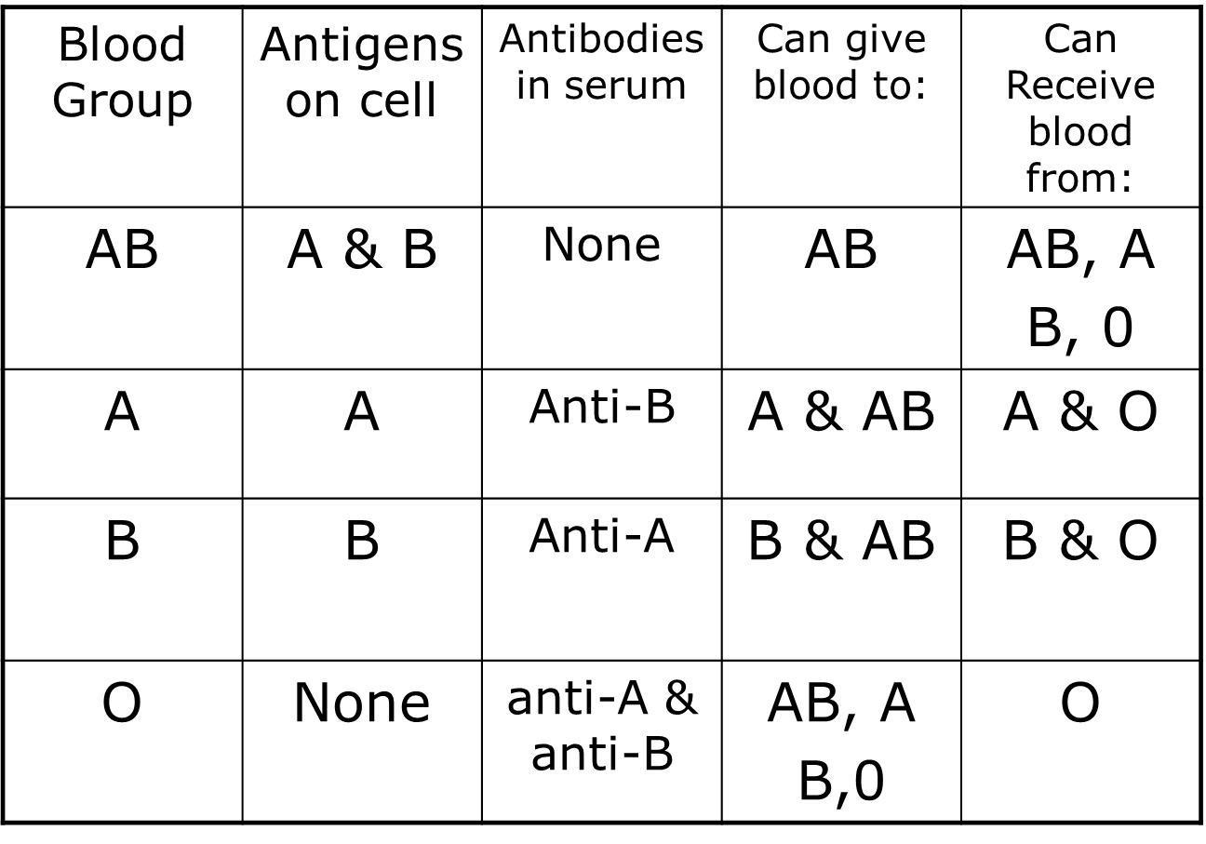

Ways to Give & Receive
- Autologous
- Intraoperative
- Postoperative
- Homologous
  - Volunteer
  - Designated donation

Blood Components Key points

All blood MUST be infused within 4 hours
Catheter size: 22- to 14-gauge with 20- to 18-gauge appropriate for general populations
Must use filter specific for blood
Administration set changed with every unit

Blood Components Whole blood
- volume — 500 cc (approx.)
- Rarely used
- Must be ABO compatible
- Acute massive blood loss >25%
- Raises Hgb by 1 g/dL
- Raises Hct by 3%

Blood Components (Packed Red Cells)
- must be ABO compatible
- Volume — 250 – 300 mL (approx.)
- Use for chronic symptomatic anemia
- NOT used for volume expansion
- Raises Hgb 1 g/dL and Hct 3%
- Use only 0.9% sodium chloride as primer
- Use 170 micron filter
- Administer over4 hours (usually 2 hours)

Leukocyte Reduced RBCs
- Filter: leukocyte filter
- Need physician’s order
- Filter 99% of WBCs that cause febrile reactions

Blood Components: platelets
- Use: control bleeding in platelet deficiency
- Use in thrombocytopenia
- Administration: 1 unit (30 – 50 mL) over 5 – 10 min.
- ABO compatibility not required but preferred.
- 1 unit raises platelet count 5 – 10,000
- Administer 6-8 units/time
  - Apheresis = single donor

Plasma Derivatives: FFP
- Plasma
  - Liquid portion of blood; does not contain RBCs
- Fresh frozen plasma
  - Prepared from whole blood separating and freezing plasma within 8 hours of collection
  - FFP may be stored up to 1 year
  - Does not provide platelets
  - Typical volume is 200 – 250 mL
- Use: procoagulant deficiencies, DIC, massive transfusions in trauma

Plasma Derivatives: Albumin
- plasma protein that supplies 80% of plasma’s osmotic activity
- Does not transmit viral disease because of extended heating process
- Available as 5% or 25% solution
- Glass bottle: administration set w/air vent.

Alternatives to Blood Transfusions
- Augmentation of volume with colloid solutions
- Autologous cell salvage
- RBC substitutes
- Modified hemoglobin or hemoglobin-based oxygen carriers
- Perfluorocarbons (PFCs)
- Erythropoietic stimulating agents (ESAs)
- White cell growth factors
- Hematinics

Administration of Blood Components
- Key points
  - Assessment
  - Preparing for transfusion
  - Obtaining blood from lab
  - Checking unit with another nurse
  - Initiation of transfusion
  - Monitoring
  - Disposal

Assessment of Patient Prior to Initiation of Blood Transfusion
- Check hospital P&P
- Consent in chart
- Review any parameters set by physician
- Vital sign base line
- Assessment of lungs and kidneys
- Laboratory values
- Patient history of transfusions
Preparation for Transfusion
- Initiate IV with appropriate catheter; in most situations, 20- to 18-gauge
- If IV infusing, check patency and cannula size
  - Saline lock: flush to check patency
- Start primer of 0.9% sodium chloride with Y administration set
- Y set has 170 micron filter

Obtain Blood Component from Lab
- Pick up only one unit from lab at a time!
- Clerical errors most common transfusion complication
- Sign for blood – checking
  - Name, identification number of patient
  - Transfusion donor number
  - Expiration date of component
  - ABO and Rh compatibility

Preparation for Administration
- Check with another licensed person compatibility information
  - Name, identification number of patient
  - “paper to armband” then
- “paper to blood bag”
  - Transfusion donor number
  - Expiration date of component
  - ABO and Rh compatibility
- Obtain set of vitals prior to initiation

Administration
- Wear gloves to hang blood
- Spike bag and hang
- Turn off sodium chloride
- slowly begin infusion
- Stay with patient a minimum of 15 minutes

Rate of Infusion
- Dr. order?
- Age of patient
- Purpose of infusion
- Other medical conditions (CHF)
- Current IV rate
- “slow” rate for 1st 15 min.
  - Craven: 10 gtts/min (60 ml/hr)
  - Phillips: 2 ml/min (120 ml/hr)
  - Berman et al Skills book: 20 gtts/min (120 mL/hr)
- Must be infused w/in 4 hours

Monitoring of Transfusion
- Check vitals per hospital P&P
  - Reflected on blood transfusion slip
- Assess kidneys and lungs throughout
- Observe for signs and symptoms of transfusion reactions

Transfusion reactions
Immune  - Acute hemolytic  - Delayed hemolytic  - Nonhemolytic febrile  - Allergic | Non-Immune  - Circulatory overload  - Hyperkalemia  - Hypothermia  - Citrate toxicity  - Bacterial contamination  - Coagulation imbalances  - Transmission of infectious disease

Transfusion Reactions
- Immediate
  - Hemolytic transfusion reactions
  - Non-hemolytic transfusion reactions
    - Febrile
    - Allergic

Hemolytic transfusion reactions
- Wrong blood to wrong patient  - Occurs within 5 – 15 min. of initiation of transfusion  - Death  - DIC | CMs  - Fever (w/ or w/out chills  - Hypotension  - Pain: lumbar, flank, chest  - Tachycardia  - Tachypnea  - Hemoglobinuria

Suspected Hemolytic Reaction?
- Stop transfusion
- Do NOT flush w/NS flush bag
- Disconnect blood tubing, then flush.
- Prepare to treat shock
- Follow hospital guidelines:
  - Notify MD
  - Save blood bag
  - Call lab
  - Blood sample
  - Urine sample

Febrile reactions
- Cause: reaction to antibodies in blood in reaction to leukocytes
- Signs and symptoms : fever, chills, HA
- Treatment: stop blood, notify RN, notify physician
- Treat with antipyretic medication
- Use leukocyte filter

Allergic reactions
- Cause: antibody formation against plasma proteins
- Signs and symptoms are varied : hives, itching, respiratory distress
- Treatment: stop blood, notify RN, notify physician
- Treatment: antihistamines

