Pharmacology
Theoretical
الدكتور الصيدلاني: حسن عبد علي شبوط
L.15
Corticosteroid
Overview
The adrenal gland consists of the cortex and the medulla.

The medulla secretes epinephrine, whereas the cortex synthesizes and secretes two major classes of steroid hormones
- The adrenocorticosteroids ( glucocorticoids and mineralocorticoids ) and
- the adrenal androgens.

Some common naturally occurring steroid hormones are
cortisol
corticosterone
cortisone
and aldosterone
Adrenocorticosteroids
A. Glucocorticoids
Cortisol is the principal human glucocorticoid.
Normally, its production is diurnal, with a peak early in the morning
Followed by a decline and then a secondary, smaller peak in the late afternoon

Factors such as stress and levels of the circulating steroid influence secretion.

In general, all glucocorticoids:
1-Promote normal intermediary metabolism: providing the building blocks and energy that are needed for glucose synthesis.
2- Increase resistance to stress: By raising plasma glucose levels, glucocorticoids provide the body with the
Energy it requires to combat stress caused, for example, by trauma, fright, infection, bleeding, etc.
3- Alter blood cell levels in plasma: Glucocorticoids cause a decrease in eosinophils, basophils, monocytes, and lymphocytes by redistributing them from the circulation to lymphoid tissue. In contrast to this effect, the increase the blood levels of hemoglobin, erythrocytes, platelets,
4- Have anti-inflammatory action:
The most important therapeutic property of the glucocorticoids is their ability to dramatically reduce the inflammatory response and to suppress immunity.
5-Affect other components of the endocrine system:
Feedback inhibition of corticotropin production by elevated glucocorticoids causes inhibition of further glucocorticoid synthesis as well as further production of thyroid-stimulating hormone. In contrast, growth hormone production is increased.
6- Can have effects on other systems:
Adequate cortisol levels are essential for normal glomerular filtration. However, the effects of corticosteroids on other systems are mostly associated with the adverse effects of the hormones.
High doses of glucocorticoids stimulate gastric acid and pepsin production and may exacerbate ulcers.
Effects on the central nervous system that influence mental status have been identified.
Chronic glucocorticoid therapy can cause severe bone loss. Myopathy leads patients to complain of weakness.

B. Mineralocorticoids
Mineralocorticoids help to control the body's water volume and concentration of electrolytes, especially sodium and potassium.
Aldosterone acts on kidney tubules and collecting ducts, causing a reabsorption of sodium, bicarbonate, and water.
Conversely, aldosterone decreases reabsorption of potassium, which, with H+, is then lost in the urine.
C. Therapeutic uses of the adrenal corticosteroids
1- Replacement therapy for primary adrenocortical insufficiency (Addison's disease):
This disease is caused by adrenal cortex dysfunction
1- Diagnosis of Cushing's syndrome:
Cushing's syndrome is caused by a hypersecretion of glucocorticoids that results either from excessive release of corticotropin by the anterior pituitary or an adrenal tumor.
3- Relief of inflammatory symptoms:
Glucocorticoids dramatically reduce the manifestations of inflammations (for example, rheumatoid and osteoarthritic inflammations, as well as inflammatory conditions of the skin), including the redness, swelling, heat, and tenderness
4- Treatment of allergies:
Glucocorticoids are beneficial in the treatment of the symptoms of bronchial asthma, allergic rhinitis, and drug, serum, and transfusion allergic reactions.
5- Acceleration of lung maturation:
Respiratory distress syndrome is a problem in premature infants. Fetal cortisol is a regulator of lung maturation. Consequently, a dose of beclomethasone is administered intramuscularly to the mother 48 hours prior to birth, followed by a second dose 24 hours before delivery.
D. Adverse effects

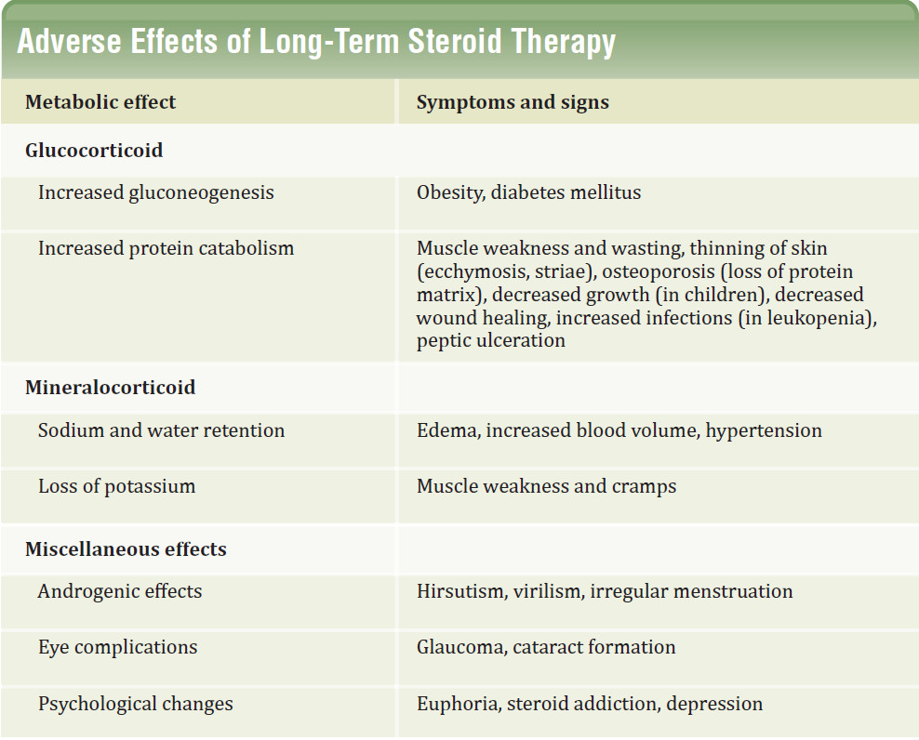

E. Withdrawal
Withdrawal from these drugs can be a serious problem, because if the patient has experienced HPA suppression, abrupt removal of the corticosteroids causes an acute adrenal insufficiency syndrome that can be lethal.
This, coupled with the possibility of psychologic dependence on the drug and the fact that withdrawal might cause an exacerbation of the disease, means the dose must be tapered according to the individual, possibly through trial and error.
The patient must be monitored carefully.
