Pharmacology
theoretical
الدكتور الصيدلاني : حسن عبد علي شبوط
L.2
DOSE-RESPONSE CURVE --------------------------------------
A fundamental principle of pharmacology is that the response to any drug depends on the amount of drug given.
This principle is known as the dose-response relationship.
A dose is the exact amount of a drug that is administered in order to produce a specific effect. The effect is referred to as the response.
When the relationship between the dose and the response is plotted as a graph, it is referred to as a dose-response curve.
The main feature of the dose-response relationship is that a drug response is proportional to the dose. As the dose increases, so does the magnitude of the response. Eventually, a maximal response is usually attained (100 percent response); further increases in dose do not produce any greater effect.
This point on the graph is known as the ceiling effect.
The ceiling effect reflects the limit of some drug classes to produce a particular effect. Above a certain dosage no further increase in effect is observed.
Doses above those needed to produce the ceiling effect usually cause other undesired, often toxic, drug effects.
Potency is a measure of the strength, or concentration, of a drug required to produce a specific effect.
The dose that will produce an effect that is half of the maximal response is referred to as the effective dose 50, or ED50.

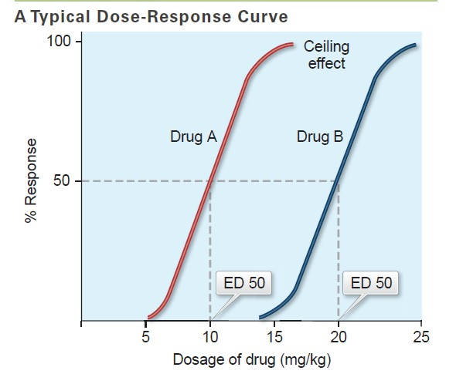

Time-Plasma Drug Concentration Curve -----------------------------------------------------------------------------------------------------------------
The relationship of time and the plasma drug concentration is known as the time-plasma drug concentration curve.
Duration of action is the length of time that a drug continues to produce its effect.

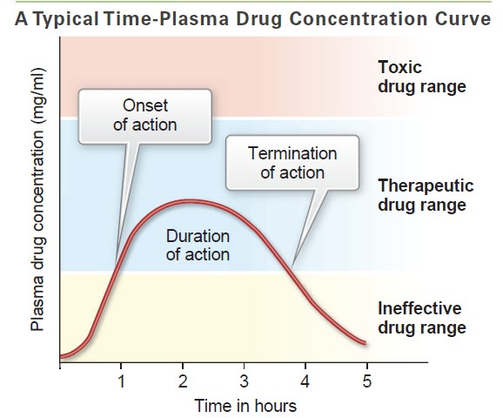

DRUG SAFETY -----------------------------------------------------------------
The federal Food and Drug Administration (FDA) has established guidelines that govern the approval and use of all drugs.
Every drug must fulfill two major requirements before it can be approved for use in humans: efficacy (proof of effectiveness) and safety.
One of the first tests that is performed is the lethal dose 50, or LD50.
The LD50 is the dose that will kill 50 percent of the animals tested.
The results of the LD50 and other tests are used to predict the safety of a drug.
Therapeutic Index
The therapeutic index (TI) is a ratio of the LD50 to the ED50 of a drug. It gives an estimate of the relative safety of a drug. The equation is expressed as:
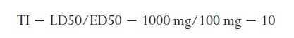

FACTORS OF INDIVIDUAL VARIATION ---------------------------------
- Many factors affect individual variation. These factors include :

age,
weight,
sex,
genetic variation,
emotional state,
placebo effect,
the presence of disease, and
patient compliance.
- Age
- The effects of drugs in different age groups is of particular importance. Infants, children, and the elderly are generally more sensitive to the actions of drugs than are younger adults.
- Weight
average adult weight is 70 kg .
- Genetic Variation
Individuals tend to inherit the proteins and enzyme patterns of their parents. There is significant genetic variation in some of the drug-metabolizing enzymes, so individual differences can occur.
- Emotional State
Differences in drug effects can be caused by the emotional state of the individual. For example, an individual who is excited or extremely anxious may require a larger dose of hypnotic or tranquilizer than an individual who is not emotionally stimulated but who still has difficulty sleeping
- Placebo Effect
Patients come to physicians and hospitals with varying expectations. It has been observed that if patients have a positive attitude and think that the drug or treatment will help, chances are the patients claim an improvement whether there actually is one or not.
- Presence of Disease
The presence of other diseases that are debilitating or that decrease the function of some vital organ usually makes an individual more susceptible to the effects and adverse reactions of drug therapy. As mentioned, the liver and kidneys are especially important, since these two organs are exposed to the highest drug levels.
For this reason, liver and kidney function are often adversely affected by drugs. Patients with hepatic or renal disease suffer a greater incidence of adverse drug effects because they are unable to eliminate the drug and its metabolites effectively. Consequently, plasma drug levels are much higher in these patients due to accumulation of the drug in the plasma.
- Patient Compliance
Drug compliance refers to taking a drug exactly as prescribed. If dosages are forgotten or skipped, the drug effects will be reduced or absent. This is referred to as noncompliance.
Noncompliance is often a problem in geriatric patients who may have memory difficulties and who are easily confused by complicated dosing schedules, especially when several different drugs are involved.
DRUG INTERACTIONS
Drug interaction refers to the effects that occur when the actions of one drug are affected by another drug.
There are many different types of drug interactions. Some drugs interfere with each other during GI absorption and therefore should not be administered at the same time.
Other drugs may interfere with plasma protein binding, drug metabolism, or drug excretion.

Half-life ……….
Time it takes for the plasma concentration or the amount of drug in the body to be reduced by 50%.

the plasma concentration of a drug is halved after one elimination half-life. Therefore, in each succeeding half-life, less drug is eliminated. After one half-life the amount of drug remaining in the body is 50% after two half-lives 25%, etc. After 4 half-lives the amount of drug (6.25%) is considered to be negligible regarding its therapeutic effects .The half-life of a drug depends on its clearance and volume of distribution. The elimination half-life is considered to be independent of the amount of drug in the body.



