Pharmacology
Theoretical
الدكتور الصيدلاني: حسن عبد علي شبوط
L.4
Antihypertensive -------------------------------------
Overview
Hypertension is defined as either a sustained systolic blood pressure (SBP) of greater than 140 mm Hg or a sustained diastolic blood pressure (DBP) of greater than 90 mm Hg.
Hypertension results from increased peripheral vascular
smooth muscle tone , which leads to increased arteriolar resistance and reduced capacitance of the venous system.
In most cases, the cause of the increased vascular tone is unknown.
Elevated blood pressure is an extremely common disorder, affecting approximately 15 % percent of the population of the United States (60 million people). Although many of these individuals have no symptoms,
chronic hypertension either systolic or diastolic can lead to:
- cerebrovascular accidents (strokes),
- congestive heart failure,
- myocardial infarction,
- and renal damage.
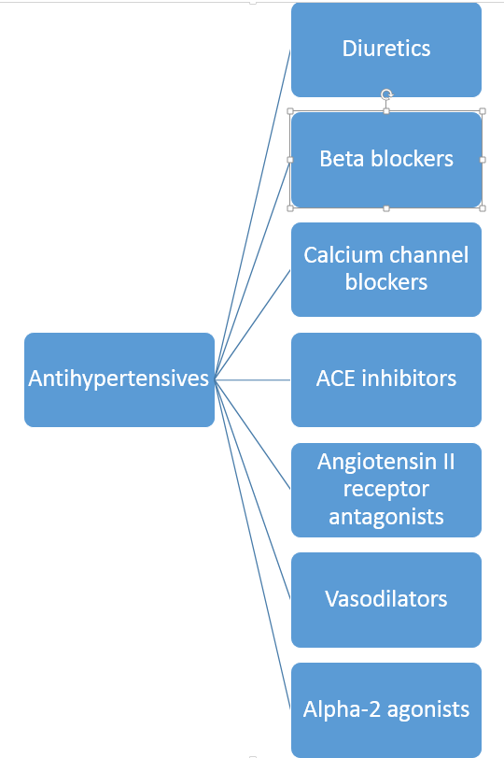

Diuretics ====================================
Diuretics are drugs that increase the volume of urine produced by promoting the excretion of salt and water from the kidneys.
Diuretics can be used as first-line drug therapy for hypertension unless there are compelling reasons to choose another agent.
Low-dose diuretic therapy is safe, inexpensive, and effective in preventing stroke, myocardial infarction, and congestive heart failure, all of which can cause mortality
A. Thiazide diuretics
( hydrochlorothiazide )
Actions: …………………………
Thiazide diuretics, such as hydrochlorothiazide , lower blood pressure initially by increasing sodium and water excretion.
This causes a decrease in extracellular volume, resulting in a decrease in cardiac output and renal blood flow
Therapeutic uses ………………..
Thiazide diuretics decrease blood pressure in both the supine and standing positions, and postural hypotension is rarely observed except in elderly, volume-depleted patients.
Thiazides are therefore useful in combination therapy with a variety of other antihypertensive agents,
They are not effective in patients with inadequate kidney function (creatinine clearance, <50 mL/min).
Loop diuretics may be required in these patients
Adverse effects ………………………….
Thiazide diuretics induce
- hypokalemia and hyperuricemia in 70 percent of patients and
- Hypomagnesemia
Usual Adult Dose for Hypertension Initial dose:
25 mg orally once a day.
Maintenance dose: May increase to 50 mg orally as a single or 2 divided doses.
B. Loop diuretics
( Furosemide )
Loop diuretics inhibit the Na+/K+/2Cl- co-transporter in the thick ascending loop of Henle, in the kidneys and stop the transport of sodium chloride out of the tubule into the interstitial tissue, causing a decrease in sodium and chloride re-absorption .
They act on the chloride-binding site and have a direct inhibiting effect on the carrier.
Inhibition of this transporter leads to a significant increase in concentration of ions in the tubule causing less water to be reabsorbed into the blood.
This causes more urine to be produced and a decrease in blood volume.
The loop diuretics act promptly, even in patients with poor renal function or who have not responded to thiazides or other diuretics.
C. Potassium-sparing diuretics.
( Spironolactone )
Potassium sparing diuretics increase diuresis by interfering with the sodium-potassium exchange in the distal convoluted tubule in the kidneys or act as an antagonist at the aldosterone receptor (they inhibit the sodium channels associated with the aldosterone-sensitive sodium pump).
Potassium sparing diuretics do not produce hypokalemia so can be used in conjunction with loop and thiazide diuretics.
Spironolactone (Gynecomastia as Adverse Effects )
Beta-adrenergic blocking agents ============
cardioselective beta blockers
non-cardioselective beta blockers
Beta adrenergic blocking agents are used to treat angina, control abnormal heart rhythms and to reduce high blood pressure. However, non-cardioselective beta blockers can cause significant bronchial constriction and could be harmful especially in patients with respiratory conditions such as asthma or chronic obstructive pulmonary disease. ( propranolol , Atenolol )
Cardioselective beta blockers (beta1- selective blockers) have a clinical advantage in that they mainly affect the heart, which predominantly has beta1 receptors.
The effect of broncho-constriction is less with beta1 selective blockers, as the bronchial muscle has more beta2 receptors, however the danger of broncho-constriction cannot be totally ignored, as they are not totally selective. ( metoprolol )
Adverse effects …………………………………..
Common effects: The beta -blockers may cause bradycardia and CNS side effects such as fatigue, lethargy, insomnia, and hallucinations.
beta blockers may decrease libido and cause impotence. [Note: Drug-induced sexual dysfunction can severely reduce patient compliance.]
Contraindications …………………………..
Beta blockers are contraindicated in patients with asthma
ACE Inhibitors ================
ACE inhibitors inhibit the activity of Angiotensin-converting enzyme (ACE), an enzyme responsible for the conversion of angiotensin I into angiotensin II, a potent vasoconstrictor.
The ACE inhibitors, such as enalapril or Captopril , are recommended when the preferred first-line agents (diuretics or beta-blockers) are contraindicated or ineffective.
Adverse effects ………………………..
Common side effects include dry cough, rash, fever, altered taste, hypotension (in hypovolemic states), and hyperkalemia The dry cough, which occurs in about 10 percent of patients, is thought to be due to increased levels of bradykinin in the pulmonary tree
Captopril
Captopril is a prodrug and about 70% of orally administered captopril is absorbed. Bioavailability is reduced by presence of food in stomach. It is partly metabolised and partly excreted unchanged in urine.
Usual Adult Dose for Hypertension
Initial dose: 25 mg orally 2 to 3 times a day one hour before meals.

