Pharmacology
Lec: 5
الدكتور الصيدلاني : حسن عبد علي شبوط
Antihypertensive -----------------------------
Calcium-Channel Blockers

• Calcium channel blockers block voltage gated calcium channels and inhibits the influx of calcium ions into cardiac and smooth muscle cells. The decrease in intracellular calcium reduces the strength of heart muscle contraction, reduces conduction of impulses in the heart, and causes vasodilatation
• Therapeutic uses
- Calcium-channel blockers have an intrinsic natriuretic effect and, therefore, do not usually require the addition of a diuretic.
- These agents are useful in the treatment of hypertensive patients who also have asthma, diabetes, angina, and/or peripheral vascular disease .
• Adverse effects
Constipation occurs in 10 percent of patients treated with verapamil.
Other example
• Nifedipine
• Diltiazem

Antiarrhythmic --------------------------
• The arrhythmias are simple dysfunctions cause abnormalities in impulse formation and conduction in the myocardium.
• For example, cardiac arrhythmias may cause the heart to beat too slowly (bradycardia) or to beat too rapidly (tachycardia), and to beat regularly (sinus tachycardia or sinus bradycardia) or irregularly (atrial fibrillation).

The five main classes in the classification of antiarrhythmic agents are:
Class I agents interfere with the sodium (Na+) channel.(Quinidine , Lidocaine )
Class II agents are anti-sympathetic nervous system agents. Most agents in this class are beta blockers.(Beta-blockers)
Class III agents affect potassium (K+) efflux. (Amiodarone )
Class IV agents affect calcium channels and the AV node. (Ca2+ channel blocker )
Class V agents work by other or unknown mechanisms.(Adenosine , Digoxin , Magnesium Sulfate )
……… Blood Drugs ……………………………………………..
drugs that are useful in treating three important dysfunctions of blood:
thrombosis,
bleeding,
and anemia.

Drugs affecting blood
Platelet inhibitors (Aspirin, Clopidogrel (Plavix) , )
Anticoagulant ( heparin , enoxaparin , warfarin )
Treatment of bleeding (Aminocaproic acid ,tranexamic acid , vit.K)
Treatment of anemia ( folic acid , iron , )

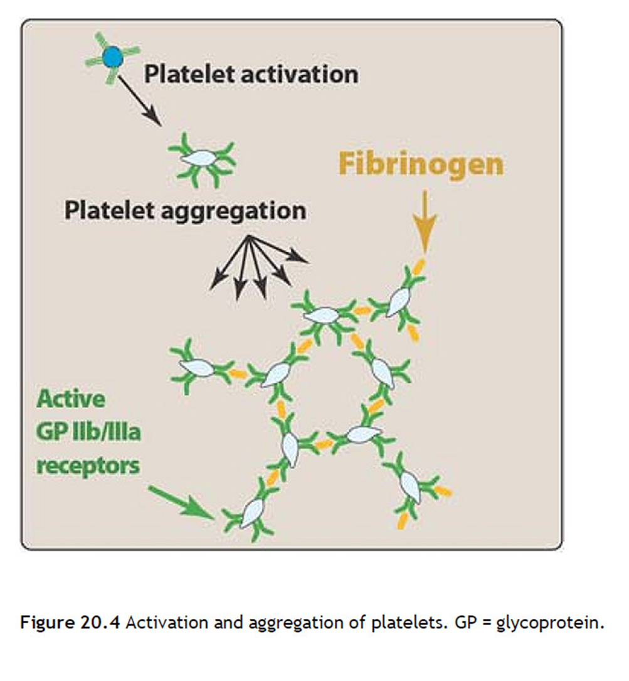

- Stimulation of platelets by thrombin, collagen and ADP (Adenosine diphosphate) results in activation of platelet membrane phospholipases that liberate arachidonic acid from membrane phospholipids.
- Arachidonic acid is first converted to prostaglandin H2 by COX-1 ,
- prostaglandin H2 is further metabolized to thromboxane A2, which is released into plasma.
- Thromboxane A2 produced by the aggregating platelets further promote the clumping process that is essential to the rapid formation of a hemostatic plug.

Aspirin

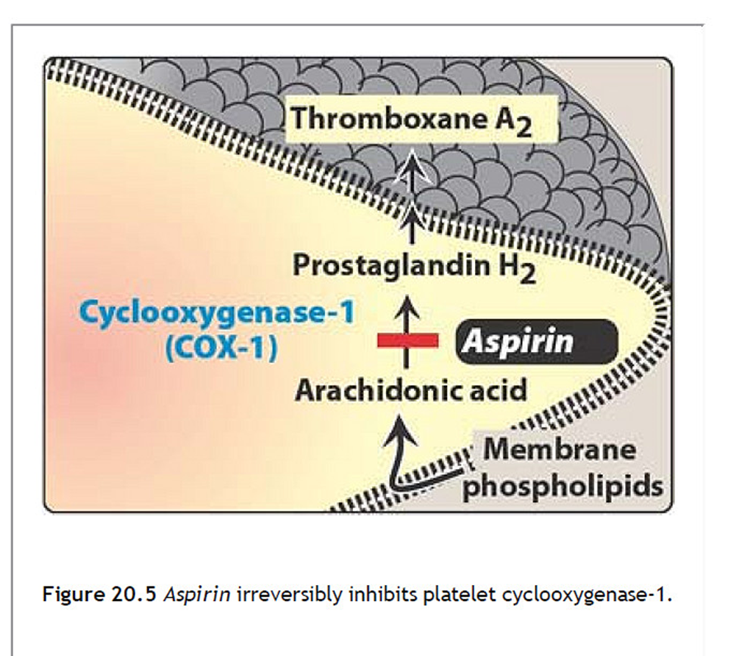

The aspirin-induced suppression of thromboxane A2 synthetase and the resulting suppression of platelet aggregation last for the life of the anucleate platelet approximately 7 to 10 days.
dose of aspirin ranges from 81 to 325 mg, with side effects determining the dose chosen.
Bleeding time is prolonged by aspirin treatment, causing complications that include an increased incidence of hemorrhagic stroke as well as gastrointestinal bleeding, especially at higher doses of the drug.

Nonsteroidal anti-inflammatory drugs, such as ibuprofen, inhibit COX-1 by transiently competing at the catalytic site. Ibuprofen, if taken concomitantly with, or 2 hours prior to aspirin, can obstruct the access of aspirin to the serine residue and, thereby, antagonize the platelet inhibition by aspirin.

clopidogrel
Mechanism of action: These drugs irreversibly inhibit the binding of ADP to its receptors on platelets and, thus, inhibit the activation of the GP IIb/IIIa receptors required for platelets to bind to fibrinogen and to each other

The maximum effect is achieved in 3 to 5 days;

Elimination of the drug and metabolites occurs by both the renal and fecal routes.

inhibit cytochrome P450 in the liver , and may interfere with the metabolism of drugs such as phenytoin and warfarin,
Anticoagulants ----------
Thrombin inhibitors: heparin and low-molecular-weight heparins
(LMWHs)

Heparin is an injectable, rapidly acting anticoagulant that is often used acutely to interfere with the formation of thrombi.
The LMWHs (enoxaparin) are heterogeneous compounds (one-third the size of unfractionated heparin) produced by the chemical or enzymatic depolymerization of unfractionated heparin. And they are replacing the use of heparin in many clinical situations.
Heparin is used in the prevention of venous thrombosis and the treatment of a variety of thrombotic diseases, such as pulmonary embolism and acute myocardial infarction.

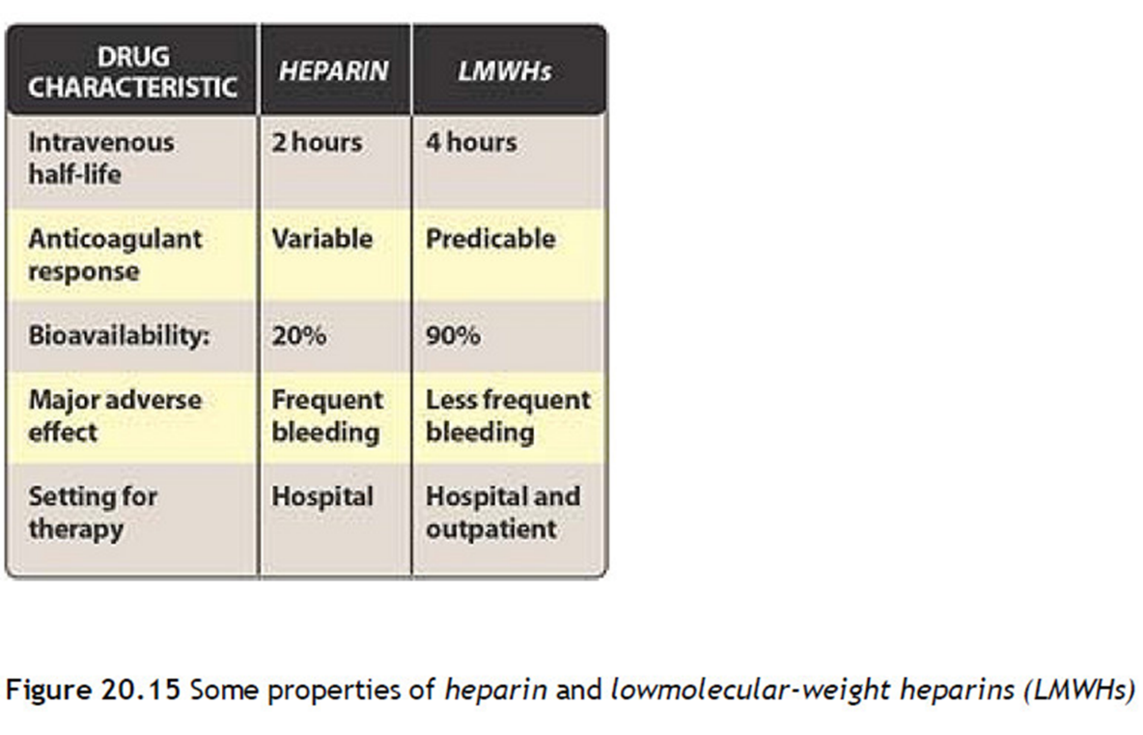
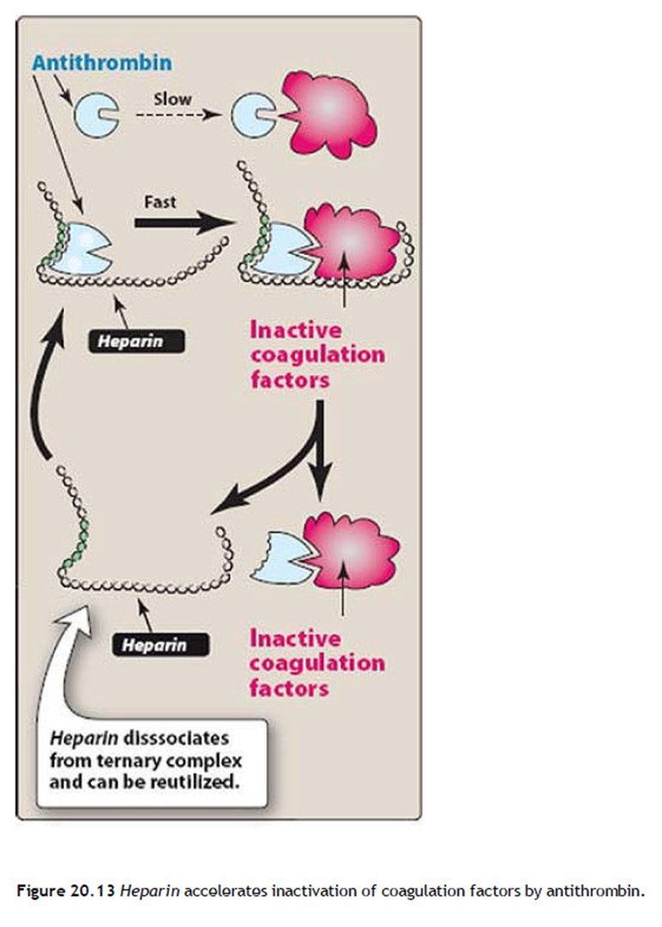

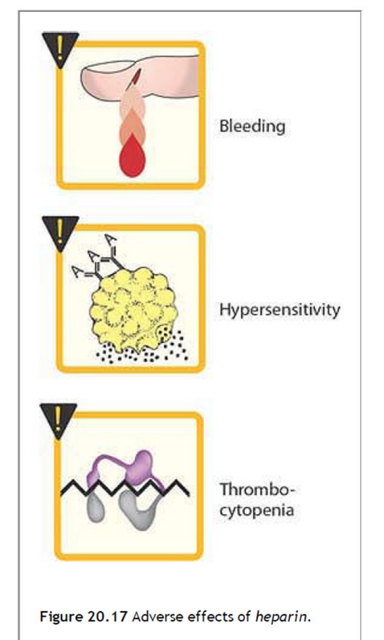

warfarin
Vitamin K antagonists
Initially used as a rodenticide,
Widely employed clinically as an oral anticoagulant.
With the availability of the LMWHs use of the vitamin K antagonists is decreasing.
Therapeutic uses: Warfarin is used to prevent the progression or recurrence of acute deep-vein thrombosis or pulmonary embolism after initial heparin treatment.
rapidly absorbed after oral administration (100% bioavailability )
half life of warfarin is approximately 40 hours,
excreted in the urine and stool.
Contraindications: Warfarin should never be used during pregnancy, because it is teratogenic and can cause abortion as well as birth defects.

