Pharmacology الدكتور الصيدلاني : حسن عبد علي شبوط
L.8
===================================================== practice ============================
Adrenergic Agonists
Introduction ------------------------------------------------------------
- The sympathetic nervous system regulates the activity of the internal organs and glands when the body is expending energy during physical exertion and situations that are stressful or threatening to the body. Mental anguish, anxiety, physical trauma, and the discovery that one has developed a serious disease are examples of stressful conditions that activate the sympathetic nervous system.
- Peripheral sympathetic nerves, referred to as adrenergic nerves, release the neurotransmitter norepinephrine (NE).
- Norepinephrine binds to its adrenergic receptors and produces the effects that are associated with sympathetic stimulation.
- The adrenal medulla releases the hormone epinephrine (EPI), which travels in the blood and also stimulates the adrenergic receptors. EPI (adrenaline) is released from the adrenal medulla in larger amounts during stress and emergency situations (fight or flight reaction).
- Norepinephrine and epinephrine are chemically similar and are generally referred to as the catecholamines .
- The drugs used to affect sympathetic activity are classified as adrenergic drugs (agonists) that increase sympathetic activity and adrenergic blockers (antagonists) that decrease sympathetic activity.
- Adrenergic drugs are used to increase blood pressure, stimulate the heart, and produce bronchodilation.
- Adrenergic blockers are primarily used to lower blood pressure and reduce cardiac stimulation in conditions where there is excessive sympathetic activity.

Norepinephrine versus Epinephrine -------------------------------------
- NE and EPI are both adrenergic neurotransmitters, there are some important differences in the effects that each produces.
- Both NE and EPI stimulate many of the internal organs to increase sympathetic activity.
- EPI is only produced in the adrenal medulla. It is released into the bloodstream, where it acts as a hormone to stimulate all adrenergic receptors.
- One of the actions of EPI is to relax smooth muscle; NE does not relax smooth muscle.
- Relaxation of respiratory smooth muscle by EPI promotes bronchodilation. This effect fits into the fight or flight reaction because more oxygen passes into the lungs when the respiratory tract is dilated.
ADRENERGIC RECEPTORS --------------------------------------------
- The two main adrenergic receptor types are classified as alpha- and beta-adrenergic receptors.
- Alpha receptors are divided into alpha-1 and alpha-2 receptor subtypes.
- The beta receptors are divided into beta-1 and beta-2 subtypes.
- Although some organs contain more than one type of receptor, one receptor type usually predominates and determines the overall response of the organ.

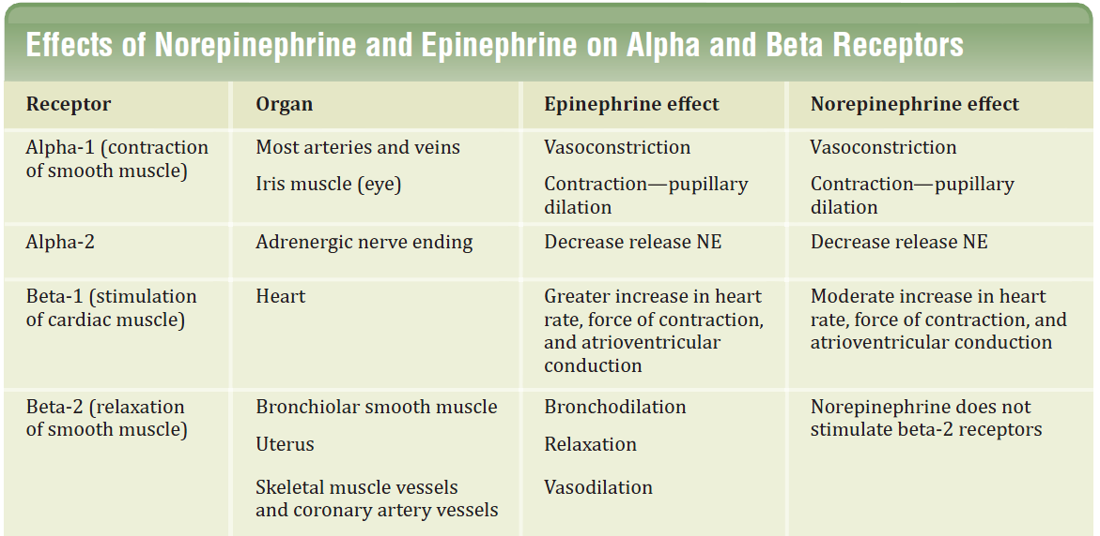

Epinephrine ------------------------------------------------
- Epinephrine is one of four catecholamines epinephrine, norepinephrine, dopamine, and Dobutamine commonly used in therapy.
- The first three catecholamines occur naturally in the body as neurotransmitters; the latter is a synthetic compound.
- Epinephrine is synthesized from tyrosine in the adrenal medulla and released, along with small quantities of norepinephrine, into the bloodstream.
1- Actions:
A/ Cardiovascular:
- Epinephrine strengthens the contractility of the myocardium (positive inotropic ).
- and increases its rate of contraction (positive chronotropic )
- Cardiac output therefore increases.
- With these effects comes increased oxygen demands on the myocardium.
- Epinephrine constricts arterioles in the skin, mucous membranes, and viscera.
- and it dilates vessels going to the liver and skeletal muscle.
- Renal blood flow is decreased.
- Therefore, the cumulative effect is an increase in systolic blood pressure, coupled with a slight decrease in diastolic pressure
B/ Respiratory:
- Epinephrine causes powerful bronchodilation by acting directly on bronchial smooth muscle. This action relieves all known allergic- or histamine-induced bronchoconstriction. In the case of anaphylactic shock, this can be lifesaving.
- Epinephrine also inhibits the release of allergy mediators such as histamines from mast cells.
C/ Hyperglycemia:
- Epinephrine has a significant hyperglycemic effect because of increased glycogenolysis in the liver.
- increased release of glucagon.
D/ Lipolysis:
- Epinephrine initiates lipolysis through its agonist activity on adipose tissue,
Therapeutic uses
Bronchospasm:
- Epinephrine is the primary drug used in the emergency treatment of any condition of the respiratory tract when bronchoconstriction has resulted in diminished respiratory exchange.
Glaucoma:
- Reduce intraocular pressure in open-angle glaucoma by reduces the production of aqueous humor by vasoconstriction of the ciliary body blood vessels.
Anaphylactic shock:
- Epinephrine is the drug of choice for the treatment of Type I hypersensitivity reactions in response to allergens.
Cardiac arrest:
- Epinephrine may be used to restore cardiac rhythm in patients with cardiac arrest regardless of the cause.
Anesthetics:
- Local anesthetic solutions usually contain 1:100,000 parts epinephrine. The effect of the drug is to greatly increase the duration of the local anesthesia. It does this by producing vasoconstriction at the site of injection,

Mechanism of action of the adrenergic agonists
Direct-acting agonists:
- These drugs act directly on receptors, producing effects similar to those that occur following stimulation of sympathetic nerves or release of the hormone epinephrine from the adrenal medulla .
- Examples of direct-acting agonists include epinephrine, norepinephrine, isoproterenol, and phenylephrine.
Indirect-acting agonists:
- These agents block the uptake of norepinephrine (uptake blockers) or are taken up into the presynaptic neuron and cause the release of norepinephrine from the cytoplasmic pools or vesicles of the adrenergic neuron As with neuronal stimulation, the norepinephrine then traverses the synapse and binds to the Î± or Î² receptors.
- Examples of uptake blockers and agents that cause norepinephrine release include cocaine and amphetamines, respectively.
Mixed-action agonists:
- Some agonists, such as
- ephedrine,
- pseudoephedrine and metaraminol,
have the capacity both to stimulate adrenoceptors directly and to release norepinephrine from the adrenergic neuron
====================================================================

