Tracheal obstruction:
A tracheal obstruction is a blockage in the airway. It may partially or totally prevent air from getting into the lungs. Some airway obstructions are life-threatening emergencies.
Causes include
- Inhaled foreign object.
- Diphtheria (a thick, gray coating on the throat and tonsils.)
- Anaphylaxis (the immune system overreacts in a way that causes a full-body allergic reaction).
- Infections.
- Trauma.

Clinical signs include
- Stridor.
- Ineffective breathing, until the person is no longer breathing (apneic).
- Loss of consciousness occurs because of brain hypoxia.
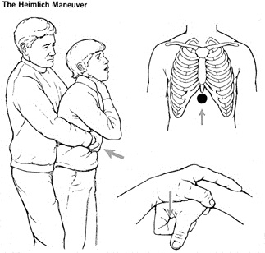
Treatment
Treatment of airway obstruction due to a foreign body, a series of five abdominal thrusts for children over 1 year of age, and a combination of five back blows with the flat of the hand and five abdominal thrusts with two fingers on the upper abdomen for infants.

